EXP:3,CPU scheduling using fcfs technique
CODE:
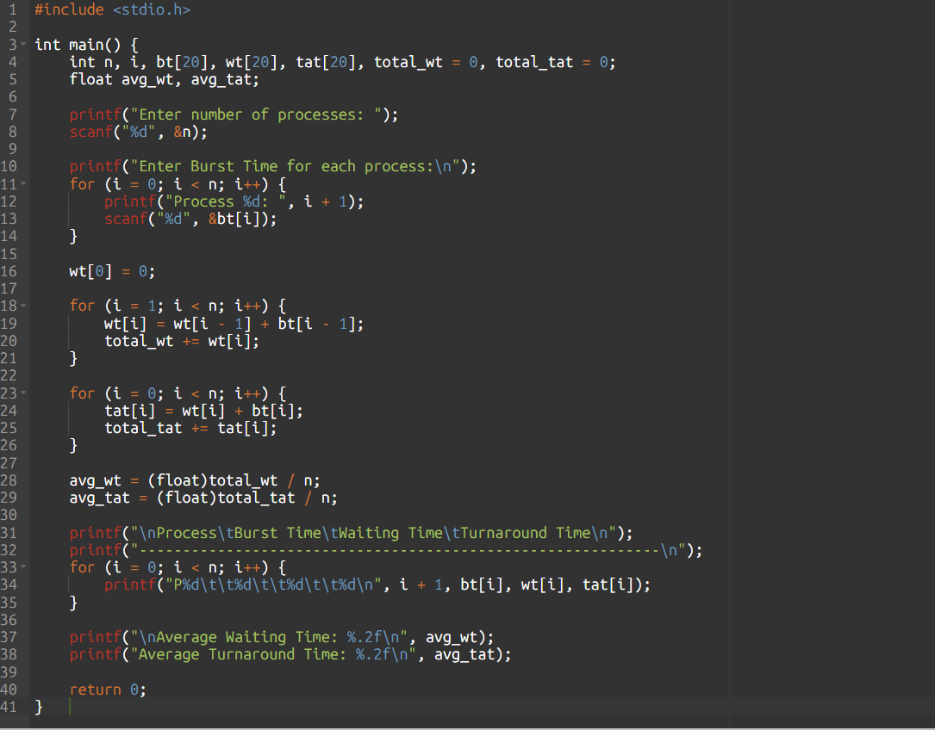
OUTPUT:
